The NHS test and trace service is FREE OF CHARGE, and:
- ensures that anyone who develops symptoms of coronavirus (COVID-19) can quickly be tested to find out if they have the virus
- helps trace close recent contacts of anyone who tests positive for coronavirus and, if necessary, notifies them that they must self-isolate at home to help stop the spread of the virus

So, the NHS will get in touch with you IF:
- you have tested positive, or
- you have been in contact with a proven positive case

If you test positive for coronavirus:
If you have taken a coronavirus test, you'll usually be contacted within 72 hours with the result.
If you have not taken a coronavirus test in the past 72 hours and you are contacted by someone telling you you've tested positive, the call is not genuine. Hang up the phone or delete the text – it is a scam.
The coronavirus test will not have been a blood test that you might have had at your GP surgery. It will have been a nose and/or throat swab.
The NHS test and trace service will send you a text or email alert or call you with instructions of how to share details of people with whom you have had close, recent contact and places you have visited.
This is important if the NHS is to stop the spread of the virus.
You will be sent a link to the NHS test and trace website and asked to create a confidential account where you can record details about your recent close contacts. If you do not have internet access or if you don’t complete the online process, one of the NHS contact tracers will phone you to gather this information from you.

If you are contacted by the NHS test and trace service because you have been in close contact with someone who has tested positive for coronavirus:
You will be alerted by the NHS test and trace service if you have been in close contact with someone who has tested positive for coronavirus. The alert will usually come by text, email or phone call.
You should then log on to the NHS test and trace website, which is normally the easiest way for you and the service to communicate with each other – but, if not, a trained call handler will talk you through what you must do. Under-18s will get a phone call and a parent or guardian will be asked to give permission for the call to continue.
If the NHS test and trace calls you by phone, the service will be using a single phone number:
0300 013 5000
This number should appear on your caller ID. However, it is easy to spoof the caller ID.
So, as a rule of thumb: if you are called by someone claiming to be from the NHS test and trace service, and the caller ID is any other number, or is hidden, hang up the phone - it is a scam.
If you do not feel comfortable talking on the phone, or you suspect the call to be a scam, you can ask for an email or a text that will invite you to use the Test and Trace web site instead.
If the caller refuses to send you an email or text instead then hang up the phone – it is a scam.
All texts or emails will ask you to sign into the NHS test and trace
contact-tracing website. You'll be given a unique ID number which you use to log into the website.
You should only ever be directed to this web address:
https://contact-tracing.phe.gov.uk
Check the URL carefully to make sure it matches the official one.
Check carefully - scammers sometimes buy web addresses that look similar to the real address to fool people.
You can check this by looking in the address bar near the top of your web browser to see if this is the address shown—it should also have a small padlock symbol next to it, indicating that the website connection is secure.
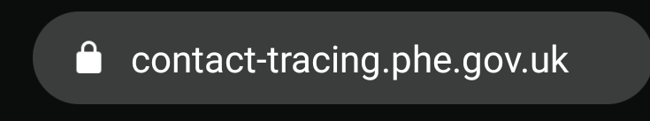

If you see a different address, it is likely to be a scam, and you should close the window immediately, and report the site to Google.
https://support.google.com/websearch/answer/106318?hl=en

Contact tracers will:
- call you from 0300 013 5000
- send you text messages from ‘NHStracing’
- ask you to sign into the NHS test and trace contact-tracing website
- ask for your full name and date of birth to confirm your identity, and postcode to offer support while self-isolating
- ask about the coronavirus symptoms you have been experiencing
- ask you about places you've recently visited
- ask you to provide the name, telephone number and/or email address of anyone you have had close contact with in the 2 days prior to your symptoms starting
- ask if anyone you have been in contact with is under 18 or lives outside of England

Contact tracers will never:
- ask you to dial a premium rate number to speak to them (for example, those starting 09 or 087)
- ask you to make any form of payment or purchase a product of any kind
- ask you for details of card or bank account numbers
- ask for your social media identities or login details, or those of your contacts
- ask you for any passwords or PINs, or ask you to set up any passwords or PINs over the phone
- disclose any of your personal or medical information to your contacts
- provide medical advice on the treatment of any potential coronavirus symptoms
- ask you to download any software to your PC or ask you to hand over control of your PC, smartphone or tablet to anyone else
- ask you to access any website that does not belong to the government or NHS
If you are asked for these types of information, you can report the incident to Action Fraud:
https://www.actionfraud.police.uk/reporting-fraud-and-cyber-crime
Engaging with the NHS test and trace service is voluntary. So, if the caller says that you must provide this personal information, or that you must pay, because it is a “legal obligation”, then hang up the phone – it is a scam.

The NHS Test and Trace service is free and will never ask for bank details or payments.
You should never pay for any NHS “home testing coronavirus kit”.
NHS teams are NOT conducting any door to door testing for the Coronavirus - these are thieves trying to get into your home. If anyone knocks on your door claiming to be conducting the tests then do not let them in and please call the police.

If you're contacted and told you've been in contact with a positive case then you'll be asked to self-isolate for 14 days and given advice on symptoms and what to look out for.
Importantly, you won't be asked for any personal details, payment details or details of anyone you've been in contact with.

Information gratefully sourced from:
https://fullfact.org/online/test-and-trace-scam/
https://www.gov.uk/guidance/nhs-test-and-trace-how-it-works
https://www.the-gazette.co.uk/news/national-news/uk-today/18506549.contact-tracing-confirm-nhs-call-isnt-scam/
https://www.ageuk.org.uk/barnet/our-services/latest-scams/
https://www.cheshirepolicealert.co.uk/da/325585/Track_and_Trace_Scam.html
https://www.which.co.uk/news/2020/06/nhs-covid-19-contact-tracing-message-how-can-i-tell-if-its-real-or-a-scam/
https://www.ofcom.org.uk/about-ofcom/latest/features-and-news/coronavirus-scam-calls-and-texts
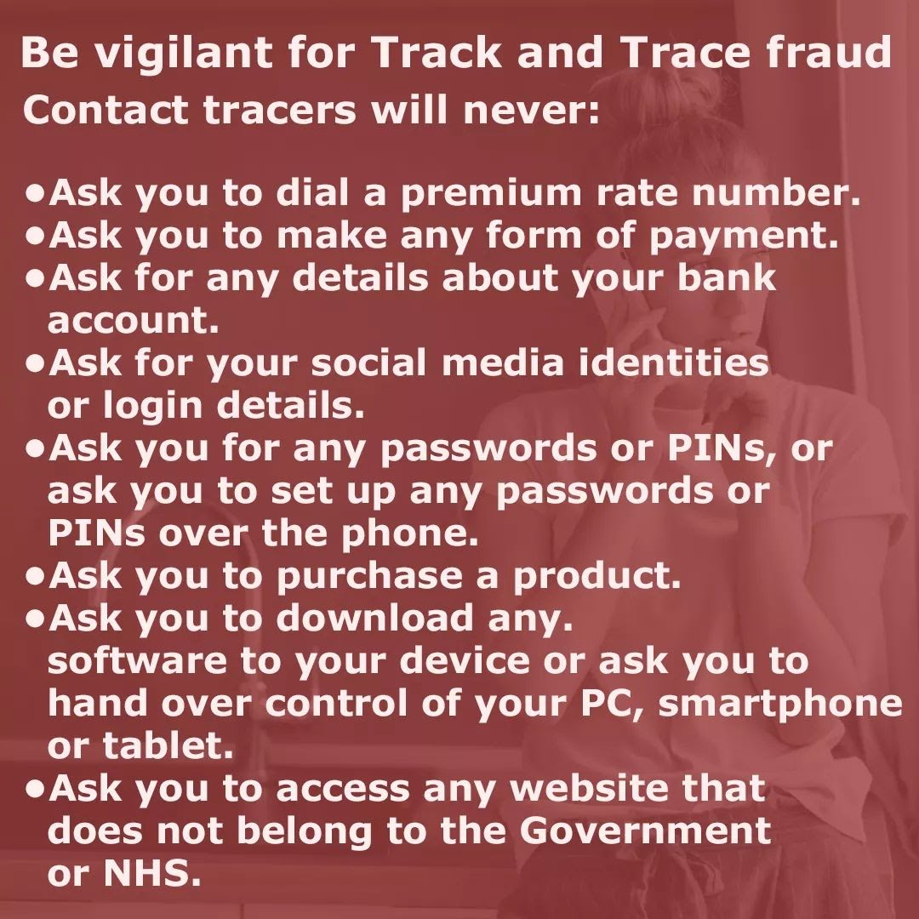
Information kindly obtained from Cheshire Constabulary

